Blockchain-based Efficient Energy Transaction Model for Electric Vehicles in V2G Network

Diego Aulet-Leon

*Graduate Student*

California State University, Long Beach

Long Beach, California, USA

[dauletle@gmail.com](mailto:dauletle@gmail.com)

Vatsal Patel

*Graduate Student*

California State University, Long Beach

Long Beach, California, USA

[Vatsal.Patel01@student.csulb.edu](mailto:Vatsal.Patel01@student.csulb.edu)

**Abstract - Vehicle to Grid (V2G) technology allows for electric vehicles (EVs) to supply power back to the grid via EV charging stations. The concept of V2G has a wide variety of uses, from storing power generated by renewables to be used during higher-demand hours, to becoming an essential source of power during environmental disasters. While the technology has been widely accepted, the implementation has been limited due to the restrictions the power utilities have in buying and selling power, particularly, the restrictions imposed with all of the banking systems the currency has to flow through to complete a transaction. Blockchain-based energy provides a solution of solving this problem by decentralizing the energy transaction away from the power utilities and third parties, and thus, make V2G a reality. This paper will go over the different types of Blockchain strategies that can be implemented to achieve the goal of decentralized energy transactions for V2G functionality.**

**Keywords—Electric vehicles, charging, blockchain, energy transaction, vehicle-to-grid (V2G), multi-agent coalition, edge as a service.**

I.  INTRODUCTION

In the last decade, the biggest push towards curbing climate change has been the push to widely used renewable energy sources, such as photovoltaics (solar), and wind power. While the supply of power has grown to make renewables a cheaper source of power than power generated by fossil fuels [7], the biggest setback has been the inflexibility of using power generated from renewables during times the renewable power cannot be generated. Specifically, power generated by photovoltaics can only be generated at the middle of the day, and wind power can only be generated when there is a sufficient amount of wind. As a result, the demand for power through a 24-hour period has shifted so that there is a much lower demand of power at the middle of the day, which can be represented in the “duck curve” shown below.

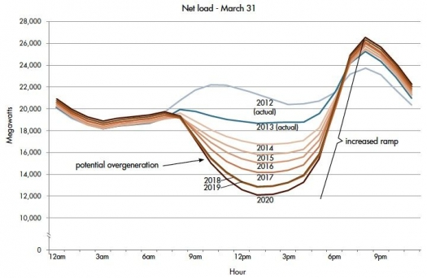

Figure 1: "Duck Curve", daily power grid demand. [3]

The issue with this fluctuation in demand for power is that a significant amount of power needs to be generated when the demand for power dramatically increases. As of now, the best way to provide this immediate demand is to use dirtier power sources, such as coal or natural gas, where the supply of power can quickly be generated by supplying more fuel in the power station. This, as a result, creates a dependency for power generated by fossil fuels, which worsens climate change.

There have been many suggested ideas to help remove this dependency, and “flatten the power demand curve”. The most logical idea is to have a large enough battery to store the power generated by renewables during their peak hours, so that this power can be used during the peak demand later in the day. While there is work being done to create a large enough “battery”, there currently isn’t anything available to store the thousands of megawatts needed to respond to the quick demand.

Meanwhile, another approach to curve climate change has been the growing adoption of Electric vehicles (EVs). EVs have been gaining remarkable popularity throughout the world over the past decade, not only because they are more cost effective for the driver, but also for their ability to produce lower emissions by the efﬁcient utilization of renewable energy. However, one of the most interesting promises is the advent of using the energy already stored in electric vehicles to power the grid during peak hours. This process of asserting power back to the grid is known as vehicle-to-grid (V2G). With this idea, the idle EVs can deliver their unused electrical energy stored in their batteries to the power grid for money; thus, create an opportunity of electricity trading in vehicular networks. Moreover, a massive deployment of V2G technology can be combined as the “battery” needed to handle the instant demand for power that occurs in the evening. This would not only reduce costs by reducing the necessity to establish additional power plants to handle the instant demand, but also remove the need for dirtier power sources, and continue the goal to reduce carbon emissions.

The idea and promise of V2G has been around for over a decade. However, the main reason why it isn’t widely adopted is due to how complicated it would be to apply this system into our current power grid. For example, if one were to attempt to supply power from their electric vehicle back to the power grid, the utility companies involved with generating the power (from the power station, to the power transmission companies, to the local electrical utility) would all have to “buy” the power from the owner of the EV. In the current model, the business model for the utility companies are structured for power to only go in one direction, where restructuring this model to receive power from the customer is unfeasible and unsustainable. In addition, having the power distribution reliant on the power grid creates a security risk, where a malicious hacker would have a single point of attack, the power utility. Therefore, a new distribution model would need to be created to (1) determine the electricity trading price and amount, and (2) settle the trading price contract in an effective and secure manner.

With the model stated, the most reasonable solution to overcome this problem is with using Blockchain. Blockchain was built as a distributed ledger that permits transactions to be gathered into blocks and recorded. It allows the resulting ledger to be accessed by different servers and which cryptographically chains blocks in chronological order [6]. By setting up each customer as a node in the Blockchain system, one can achieve the ability of utilizing V2G transactions, and thus, improving the ability to curb climate change.

This paper has been organized to go over two approaches discussed for using Blockchain in the power grid. Following the analysis, a conclusive opinion would be discussed, as well as future actions to take for implementation.

II.  Multi-Agent Coalition [2]

In the paper provided by Fengji Luo and his team in IEEE, one form proposed of using Blockchain for EV Charging is to use a multi-agent coalition to perform the negotiations for the energy transactions that would happen between prosumers (producers and consumers). According to the paper, “Multi-agent coalition refers to a way to cooperate agents to complete a task, where none of them can complete it independently.” In the first part of the model, each prosumer is modelled as a Multi-Agent System (MAS), which is set as the lowest layer in the system. Each MAS has multiple Resource Agents (RAs) in the layer above, where the RAs are meant to perceive the operational status of energy resources from the MASs, and send the information to the Local Coordination Agent (LCA) in the next layer. Based on the energy resource information from RAs, the LCA automatically performs the energy management by “solving a local scheduling model to determine optimal control actions of the internal energy resources with the aim to serve local power consumption”. If the LCA determines that the local generation cannot serve the consumption of the MASs, it is deemed as an energy shortage. In this case, the Social Coordination Agent (SCA) for the LCA negotiates with the grid and other corresponding SCAs to purchase the power at the lowest cost. The SCA is located at the highest layer, and can offer to sell excess power based on the amount of excess power it has. The organization of this multi agent coalition is shown below.

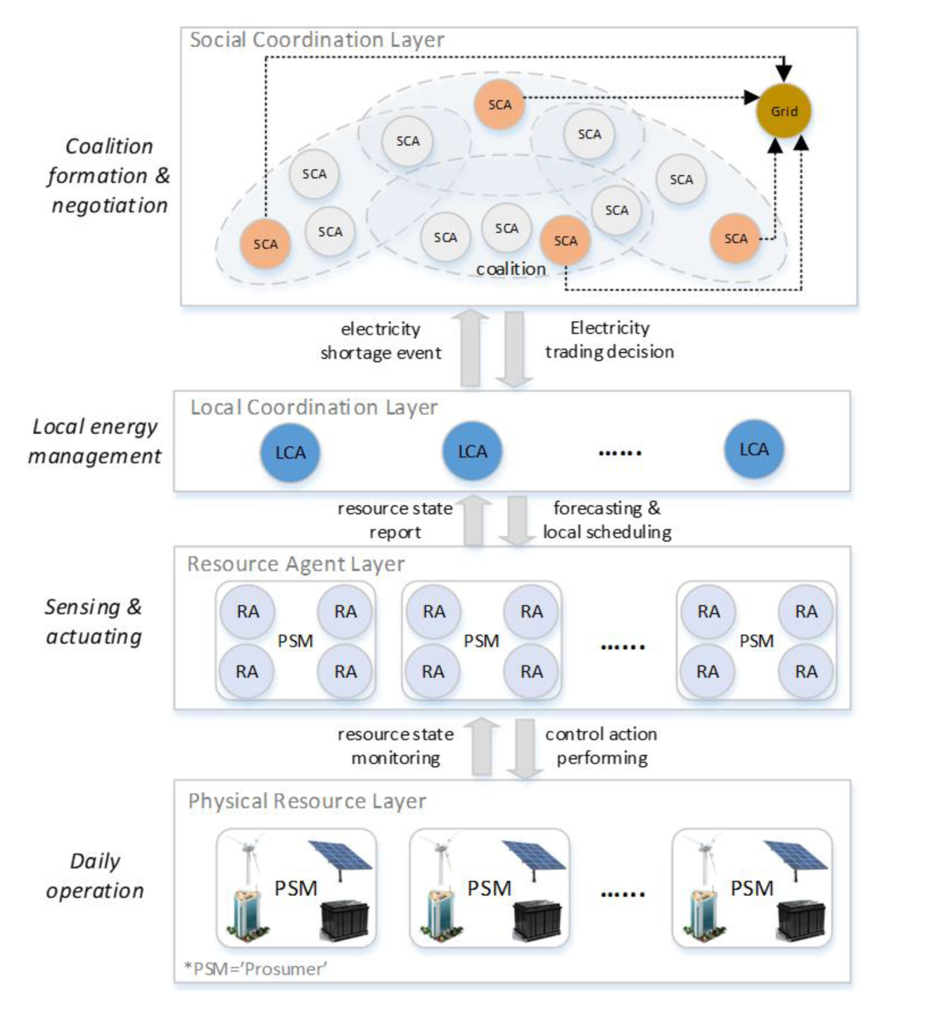

Figure 2: Multi Agent Coalition Model

The second part of this model uses Blockchain to settle the energy transactions. The Blockchain essentially consists of a parallel double-chain; one chain is for the contract and the other chain is for the ledger. Each block in the contract chain contains only one energy trading contract that is placed in sequential order. The ledger chain is the final financial settlement which corresponds to each contract block. Each pair of contract-block and ledger-block is equipped with a high frequency verifier that works uninterrupted once generated.

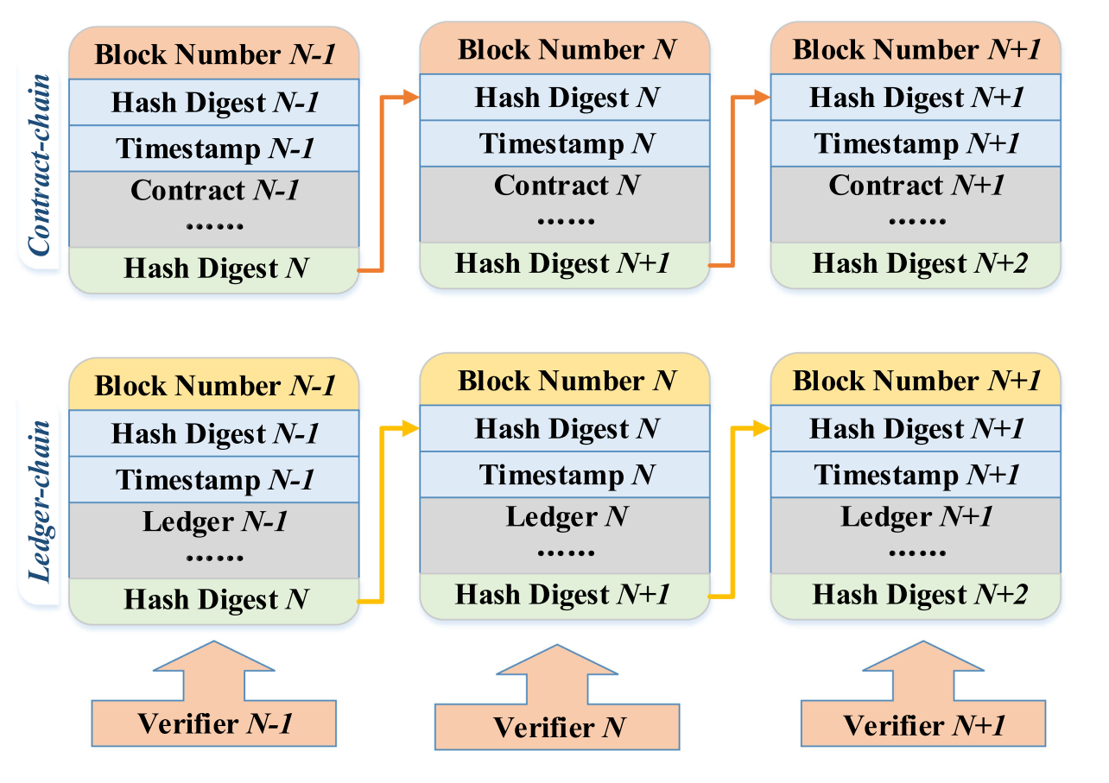

Figure 3: Blockchain double-chain model.

The energy negotiation process is handled with the multi agent coalition, where each of them are dependent on one another. The diagram below provides an overview of how the negotiation is processed.

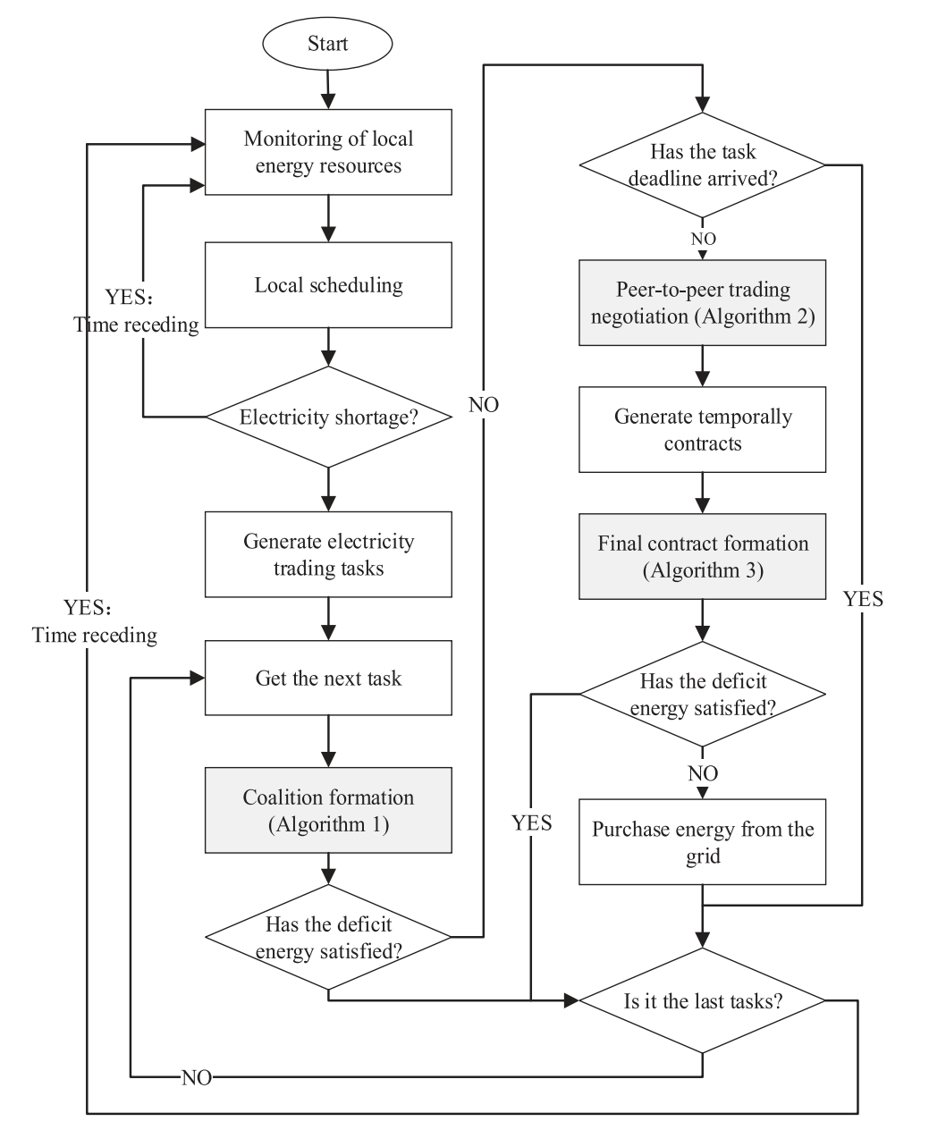

Figure 4: Multi agent energy negotiation state diagram.

As seen in the diagram, the negotiation workflow begins with the prosumer continuously monitoring its on-site local energy resources and performs autonomous energy management. This repeats until there is an energy shortage, where once there is a shortage, the prosumer acts as a buyer to launch electricity negotiation requests. This describes the first formulation, the Autonomous Energy Management of Prosumer. The goal of this model is that the LCA uses the electricity retail price signed by the prosumer to calculate the price of power which the prosumer needs to buy from external suppliers.

For each prosumer, the RAs monitor the energy resources through sensors, and store data into local storage. Based on the historically recorded data, the LCA performs very short-term forecasting to predict the power generation and consumption over future time intervals. Once a forecasting result is determined, the LCA solves a local scheduling model to allocate power outputs of the on-site generation resources to serve the local load, while satisfying operational constraints. With this algorithm, the LCA determines control schedules of local producers and consumers, and the amount of intended energy purchase. Then, if the prosumer does need to buy additional power, the LCA forwards the deficit energy to the SCA, and the latter will launch the coalition request to try to buy energy from other prosumers with a price lower than the electricity retail price signed by the prosumer. Once this is done, the Agent Coalition Formulation algorithm is executed to determine the contract to use for prosuming energy.

A.  Agent Coalition Algorithm

The algorithm begins with the electricity purchase information sent from LCA, where it is denoted in an array of blocks of intended electricity purchases. Each block includes tuples representing the start time, end time, and energy amount (kWh) of the electricity purchase. By receiving the blocks of purchases from the LCA, the SCA starts a coalition request for each block. Firstly, the SCA of prosumer (the buyer) initializes its neighbored SCA list. Then, the buyer contacts each adjacent SCAs to negotiate electricity trading before the deadline. In this process, the buyer calculates its available energy based on perceiving its connection line’s power capacity. The buyer also propagates the request to neighbors of a randomly selected SCA if all following three conditions are satisfied: (1) the trading deadline is not reached; (2) if there is at least one SCA not in the adjacent SCA list; and (3) the request propagation depth is less than the pre-specified threshold. Here the control parameter threshold controls the times the buyer can propagate the request through its connected SCAs.

After the trading deadline arrives, the buyer begins the price negotiation using the next algorithm, the Electricity Trading Negotiation Protocol.

B.  Electricity Trading Negotiation Algorithm

The algorithm starts with the seller receiving the buyer’s request. If the seller has available electricity during the period of the task, the buyer sends a reply to the seller and starts the electricity trading negotiation process. The proposed negotiation protocol of electricity trading is based on the alternating offers protocol. Firstly, the seller provides an offer to the buyer. The energy selling price in the offer is based on the evaluation of the seller’s generation cost and the number of existing temporary contracts the seller has, which is dependent on the generation cost of serving the electricity demand of the task. The value of the generation cost is determined by the LCA of the seller through local scheduling.

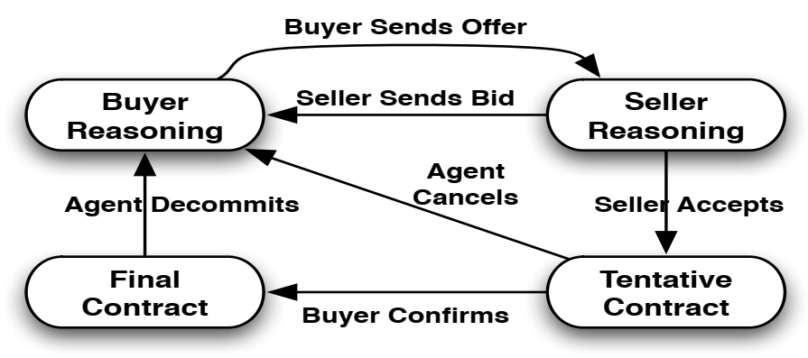

Figure 5: Trading negotiation algorithm diagram.

By receiving the offer, the buyer has three options: accept the offer, reject the offer, or generate a counter-offer to the seller. The rationale of the model is if the total contracted energy amount of the temporary contracts owned by the seller is large enough and the counteroffer price is smaller than the average price of temporary contracts, then the seller will reject the counteroffer; otherwise, the counteroffer will be accepted. The rationale of the model is that when generating an offer, the seller raises the selling price with the increase of the number of its existing temporary contracts. Also, the model shows that when the buyer has more temporary contracts in hand, its intended purchase price decreases.

When the trading deadline arrives, the negotiation is finished, and the Final Contract Determination Algorithm can begin.

C.  Final Contact Determination Algorithm

Final contracts are selected from the temporary contract set in this algorithm, which is populated with the negotiation tasks from the previous algorithm. The final contract determination process is launched by the buyer. Firstly, if the contract determination deadline does not arrive, the buyer stacks its owned temporary contracts, and selects temporary contracts with the price from high to low. Once a contract is selected, the buyer sends a transaction request message to the seller. When the seller receives the transaction request message, it firstly checks whether it has adequate energy capacity to accomplish this contract excluding existing final contracts. If so, then the seller sends a confirmation message to the buyer, and the contract will be finally confirmed as a final contract. Otherwise, the seller sends a cancel message to the buyer, the temporary contract will be cancelled, and the buyer proceeds to the next contract in its stacked contract list. This occurs until one of following three conditions is satisfied: (a) the sum of final contracted capacity is reached; (b) all the temporary contracts have been processed; and (c) the final contract determination deadline arrives. When the final contract determination deadline arrives, all the remaining temporary contracts will be cancelled.

D.  Blockchain Based Transaction Mechanism

All prosumers in the Blockchain based energy trading community compose a private distributed network, in which only registered prosumers can participate in the energy trading processes. The contract-chain starts to get verified by the system when the buyer broadcasts the final contract to all other prosumers (nodes). Once received, other nodes decrypt the contract to confirm whether the contract is agreed by both the buyer and the seller. The verification result is then reviewed by the voting of all nodes, in which each node has precisely one chance to vote. Only when the majority of nodes agree, the contract is considered as valid and written in a new contract block. Lastly, each prosumer then generates a hash digest by using SHAs to chain the new contract block to the existing chain. Once a new contract block is chained onto the contract chain, each node calculates the ledger to update the balance after the execution of the new contract. A randomly selected node is responsible for broadcasting its calculated ledger to all other prosumers so as to let all nodes make a contradistinction between their calculated ledgers and the received one. The new ledger is considered through a prosumer motivated voting mechanism as valid, then written in a new ledger block. When a ledger block is chained onto the existing ledger chain, a high frequency verifier, which is located on each node, is triggered immediately to work uninterruptedly for the new generated contract-block and ledger-block pair.

E.  Simulation of a Multi Agent Coalition

In the simulation done in the paper, the load curve of the prosumers were generated based on the Australian “Smart Grid, Smart City” dataset, in which the electricity consumption data of more than 300 Australian residential users in the state of New South Wales were recorded. In the paper's simulation discussion, each prosumer had simulated rooftop solar or wind power sources. While the on-site battery energy storage system (BESS) is simulated as a power cell installed in a residential home, the BESS can also be assumed to be a vehicle's battery system, which can store from 15-100kWh of power. A twenty four hour horizon was simulated, with the duration of each time interval set to be 30 minutes, and the negotiation deadline and final contract determination deadline were set. Below are the result found in the simulations:

* The number of tasks increased in an approximately linear relationship, which is mainly because in this simulation 50 prosumers were set as base configurations, and other prosumers were replicated with some variations.
* Assuming that communication network traffic is not considered, the average negotiation time was less than one second (about 700 ms) when there were 300 prosumers. While this proves the efficiency of the proposed system, the reality is that the negotiation time would depend on the real-time network traffic conditions.
* In the simulation, about 75-80% of deficit electricity transactions were satisfied by trading electricity with other prosumers. Only for a small proportion of electricity did the prosumers have to purchase the energy from the grid at the retail price.
* By primarily purchasing power from other prosumers, this not only ideally saves costs for the prosumers (by purchasing power from other prosumers at a lower cost), but also allows for a reduced demand of power from the power grid, which acquires its power from larger power stations.

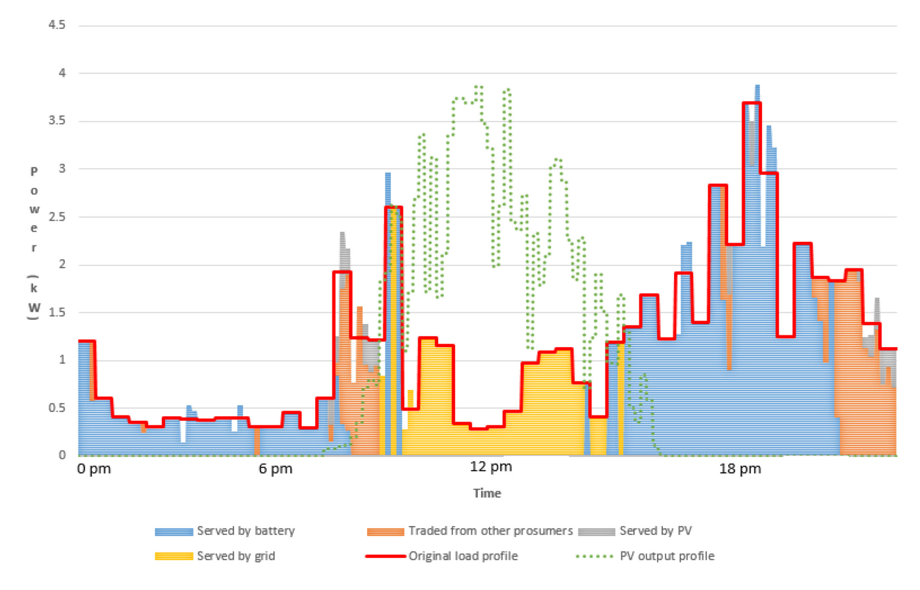

Figure 6: Simulation of power demand in New South Whales (NSW), adjusted with implemented multi agent coalition.

The figure above illustrates the 24-hour internal energy resource scheduling performed by the LCA of a single prosumer. The red line represents the normal load curve of the prosumer, or in other words, the power demanded by the prosumer. The graph shows the stacked areas form the shifted load curve produced by the LCA, which are served by different energy sources. From this graph, it is evident that most of the power is either purchased from other prosumers, or acquired from the battery storage of the battery system. However, what is most significant is when the power is purchased from the grid, where the power is purchased when there is a peak supply of power from photovoltaic power. The reason for its significance is that it highlights how the model can shift the power dependency to renewable energy, while allowing for the demands of power that occur throughout the day to be satisfied.

### III.  Edge as a Service [5]

In the paper provided by Xuesong Xu and his team in Sensors (Basel), a Layered Lightweight Blockchain Framework (LLBF) was designed. The nodes in the LLBF are composed of various edge computing devices, including execution units, centralized controllers, network devices and servers. In order to ensure the scalability of blockchains and reduce network delay, edge devices or edge computing units in resource constrained layers (RCL) are grouped by functional attribute clustering, and each cluster selects cluster head (CH) to manage the corresponding blockchain. If there is excessive delay of some nodes in the industrial internet, then these nodes can be re-clustered and change their clusters. Generally, CH nodes that remain online for a long time are selected and the basic tasks in the cluster are stable. Therefore, the RCL blockchain is not affected by the dynamic changes of devices. Asymmetric encryption, digital signature and cryptographic hash functions, such as SHA256, are utilized to protect all kinds of transactions generated by nodes. A transaction structure of block data in LLBF is shown in Figure below, which contains seven attribute fields and one data field. The first field records the current transaction ID, and the second field is the aforementioned transaction pointer, which is linked into blocks through pointers. The next four fields are the PK and digital signature. The digital signature belongs to the requester and requestee. The seventh field is the Output [i], i = 0,1,2 set of the requester. Output [0] denotes the number of accepted transactions generated by requester, Output [1] denotes the number of transactions rejected by requested, and Output [2] is the PK hash used in the next transaction of requester. The final field is “metadata”, which provides a record of the operations required by the device node, including ID, device name, and operation type.

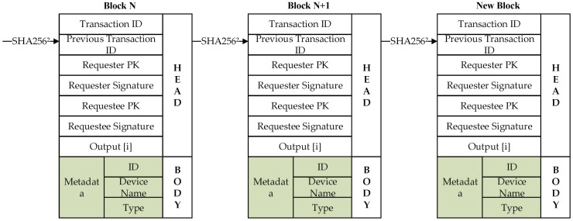

Figure 7.: Cluster Head (CH) diagram

Each CH decides independently whether to retain or discard a new block based on the communication received from the transaction participant (including the requester and the requested), which may result in different versions of blocks in each CH. Corresponding to the accounting operation of each cluster center node, the blockchain model of this layer does not need to coordinate the block consistency in real time, thus reducing the block synchronization overhead. Data resources are summarized through the resource extended layer (REL) layer, so the resource extended nodes in the REL verify the block consistency within a specified waiting period, thus addressing the problem of insufficient computing performance of equipment resources in RCL layer.

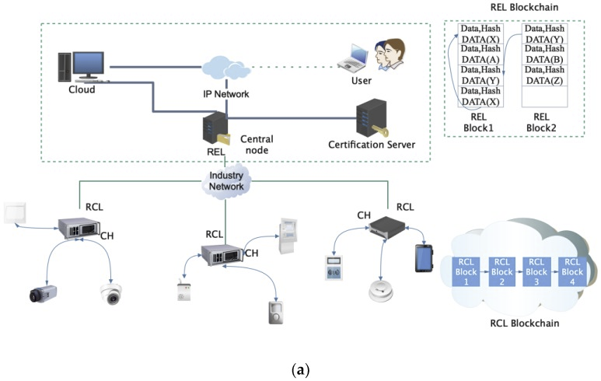

Figure 8: Network structure model of Layered-blockchain

The above figure describes the network structure model of layered-blockchain, andFigure below presents the design of blocks of RCL layer.

Each RCL block contains a block head and a policy head. The block-head stores the previous block hash, and the policy head maintains an access control list. These control lists define RCL transactions and rules for communicating with REL. The policy head has four parameters. The first parameter is the network device ID of the requester transaction. The second parameter represents the request requirement, including data writing, data reading, access control, monitoring and data transmission. The third parameter is the specified target device, and the fourth parameter is the operation permission. All block structures are indicated on the left side of the figure, identifying the specific content of a transaction, including the current transaction, transaction chain, transaction type, access device and related operation record information. Each REL block contains a block head and a transaction body. The block-head stores the previous block hash value, generator ID, and verifier’s signature. If illegitimate access attempts to change previously transactions, the hash value of the corresponding block will remain on the block and there will be inconsistencies, thus exposing this attack. In the RCL layer, because of the equipment resources constraints, the CH block head only stores hash value, the block body only stores basic control and state information. The initialization maximum block body size is 256 Kb, and the total cache size of each device block is 2 M. If the block continues to increase, the block will be synchronized to the REL layer with greater processing capacity.

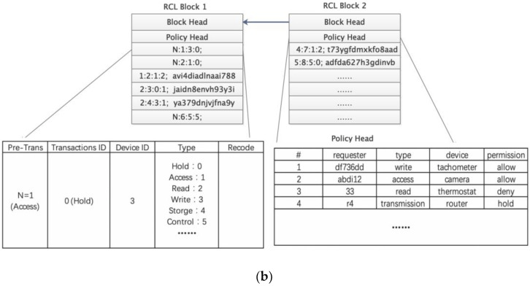

A.  Testing for Efficiency of the Network

The figure below shows the impact of the number of validators and invalid transactions in a block on the probability that no invalid transactions are detected during block validation. As the number of validators increased, we could reduce the percentage of transactions that needed to be validated without compromising the performance of invalid transaction detection. When each validator only validated 40% of the transactions, the probability of not detecting an invalid transaction in 80 transactions was less than 0.3%. If there were multiple invalid transactions (when the number of invalid transactions is 5, 10 respectively), the probability of not detecting invalid transactions was significantly reduced.

Which makes this proposed method more secure and steady for the real world implementation for EVs to plug into the V2G grid to stabilize the need for energy generation from fossil fuel, hereby, making renewable energy more reliable.

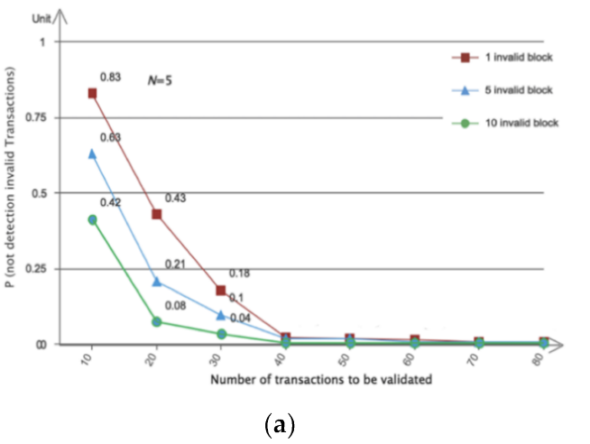

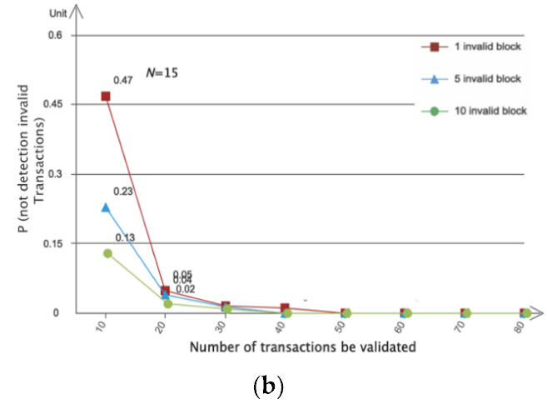

Figure 9: The impact of the number of validators and invalid transactions in a block.

### IV.  Conclusions

In this paper, we have proposed strategies to implement a blockchain-based energy trading model for EVs in V2G network. P2P energy transactions between charging stations and EVs without need of any trusted third party are enabled by means of blockchain technology. The transaction data is stored in the blockchain network in a distributed manner using a multi-agent Coalition and edge as a service. Smart monitoring of the energy usage and the remaining amount of energy of EVs is enabled by installing smart meters into EVs and connecting the EVs to the smart grid via the Internet. This method of using EVs extra electricity for curbing up the need of generating electricity using fossil fuel.

1. M. M. Islam, M. Shahjalal, M. K. Hasan and Y. M. Jang, "Blockchain-based Energy Transaction Model for Electric Vehicles in V2G Network," *2020 International Conference on Artificial Intelligence in Information and Communication (ICAIIC)*, Fukuoka, Japan, 2020, pp. 628-630, doi: 10.1109/ICAIIC48513.2020.9065221.
2. F. Luo, Z. Y. Dong, J. Murata, Z. Xu, and G. Liang, “A distributed electricity trading system in active distribution networks based on multiagent coalition and blockchain,” IEEE Trans. Power Syst., vol. 34, no. 5, pp. 4097–4108, Sep. 2018.
3. Jones-Albertus, Becca. “Confronting the Duck Curve: How to Address Over-Generation of Solar Energy.” Energy.gov, Office of Energy Efficiency and Renewable Energy, 12 Oct. 2017, www.energy.gov/eere/articles/confronting-duck-curve-how-address-over-generation-solar-energy.
4. Jh. Liu, Y. Zhang, S. Zheng, and Y. Li, “SURVIVOR: A blockchain based edge-as-a-service framework for secure energy trading in SDNenabled vehicle-to-grid environment,” Comput. Netw., vol. 153, pp. 36–48, Apr. 2019
5. Luo, Chuanwen & Xu, Liya & Li, Deying & Wu, Weili. (2020). Edge Computing Integrated with Blockchain Technologies. 10.1007/978-3-030-41672-0_17.
6. Sheedy, Chris. “Blockchain: the Future of Record Keeping.” INTHEBLACK, 12 June 2019, www.intheblack.com/articles/2018/03/22/blockchain-future-record-keeping.
7. Ellsmoor, James. “Renewable Energy Is Now The Cheapest Option - Even Without Subsidies.” Forbes, Forbes Magazine, 15 June 2019, www.forbes.com/sites/jamesellsmoor/2019/06/15/renewable-energy-is-now-the-cheapest-option-even-without-subsidies/?sh=103033b65a6b.